Response Paper #3 — Henri Cartier-Bresson

*Write at least one paragraph (3-5 sentences) per question. These will be graded for integration of knowledge, depth of discussion, cohesiveness, spelling & grammar, sources and citations (no APA style necessary). Although the questions are based on concepts and information from the film, online research is necessary to thoroughly and accurately answer the questions. Be sure to carefully read each question first, before answering.*

*Please copy and paste your completed response into the blackboard text submission window (in Blackboard, click on the assignment name, go to section "2" and click the "Write Submission" button. Paste your copy there and submit).*

# 1. Henri Cartier-Bresson states that “In photography, you have to keep in the same line of sight your head, your eye, and your heart.” Elaborate on this statement, explaining what you think he is saying about his approach to photography and photography in general.

I think this quote tells us a lot about Cartier-Bresson's priorities in photography, which would appear from this quote to be journalism and story-telling, visual aesthetics, and emotional and moral values. Those journalistic and emotional values played a big factor in his post-World War II work and his participation in Magnum Photos. When interviewed about the time after World War II, he said, "Capa said to me: ‘Don’t keep the label of a surrealist photographer. Be a photojournalist. If not you will fall into mannerism. [...]’ This advice enlarged my field of vision." (*Magnum Photos.*) Visual aesthetics, on the other hand, are not something he needed to be reminded of; his obsession with capturing the decisive moment has been present throughout his career.

## Sources

* "History." *Magnum Photos*. <https://www.magnumphotos.com/about-magnum/history/>

# 2. In 1947 he founded Magnum with three (initially four, but we only count the ultimate three) other photographers. Research and provide information about all four photographer's roles in photography and the Magnum Photos organization.

Magnum Photos was founded just after the end of World War II by Robert Capa, Henri Cartier-Bresson, George Rodger and David Seymour (also known as Chim). Moreso than Cartier-Bresson, whose best known photos before the war were primarily street photography, the other three founders were very experienced in war photography. Capa and Seymour both covered the Spanish Civil War in the late 1930s, and all of them covered World War II in one form or another. They united to form Magnum Photos as a photojournalism cooperative wherein the photographers retained the copyrights and chose their own direction, allowing them to shoot what they were passionate about instead of being restrained by whatever magazine employed them. Upon founding Magnum, the founders spread out around the world; Seymour covered Europe, Cartier-Bresson covered India and east Asia, Rodger covered Africa, and Capa went to America.

## Sources

* "Biography." *The Henri Cartier-Bresson Foundation*. <https://www.henricartierbresson.org/en/hcb/biography/>
* "History." *Magnum Photos*. <https://www.magnumphotos.com/about-magnum/history/>
* "Henri Cartier-Bresson (1908–2004)." *International Center of Photography*. <https://www.icp.org/browse/archive/constituents/henri-cartier-bresson?all/all/all/all/0>
* "Henri Cartier-Bresson: Photographer Profile." *Magnum Photos*. <https://www.magnumphotos.com/photographer/henri-cartier-bresson/>
* "Magnum Photos." *The Henri Cartier-Bresson Foundation*. <https://www.henricartierbresson.org/en/fondation/magnum/>

# 3. Select your three favorite Cartier-Bresson portraits and describe each from a technical and emotional level — what makes these images so special to you?

## Samuel Beckett (1964)

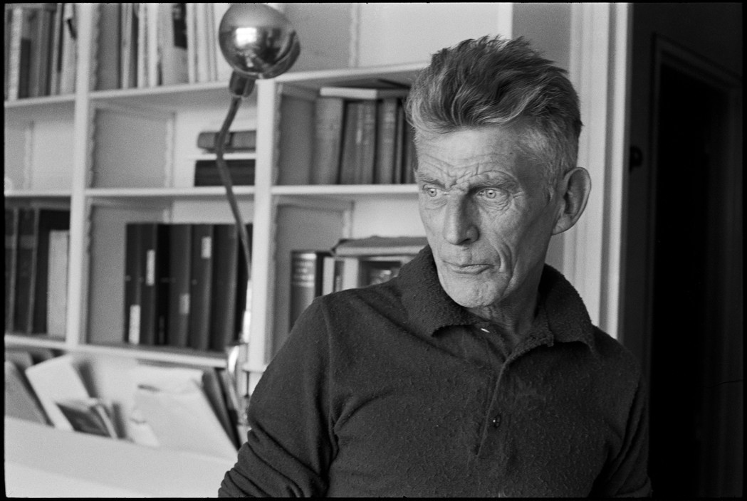

Knowing nothing about Samuel Beckett's work as a playwright, I was immediately drawn to this photo simply because of the striking facial expression that your eye is immediately drawn to; it gives the impression of a wise old man carrying some rough emotional burdens. Based on my research about Beckett after first seeing the photo, it seems this is a somewhat accurate portrayal of Beckett and his work (Wikipedia summarizes his work as offering "a bleak, tragicomic outlook on human existence, often coupled with black comedy and gallows humor"). Technically, the photo is very well shot; the out-of-focus bookshelves on the left and the negative space both frame the face quite nicely to draw your attention directly to his face. Beckett's off-camera gaze offers some intrigue, and his eyes line up rather interestingly with the parallel lines of the bookshelves.

### Sources

* Esslin, Martin J. "Samuel Beckett." (2019) *Encyclopedia Britannica*. <https://www.britannica.com/biography/Samuel-Beckett>
* "Henri Cartier-Bresson: Photoportraits." *Magnum Photos.* <https://www.magnumphotos.com/arts-culture/fashion/henri-cartier-bresson-photoportraits/>
* "Samuel Beckett." *Poetry Foundation*. <https://www.poetryfoundation.org/poets/samuel-beckett>
* "Samuel Beckett." *Wikipedia.* <https://en.wikipedia.org/wiki/Samuel_Beckett>

## Truman Capote (1947)

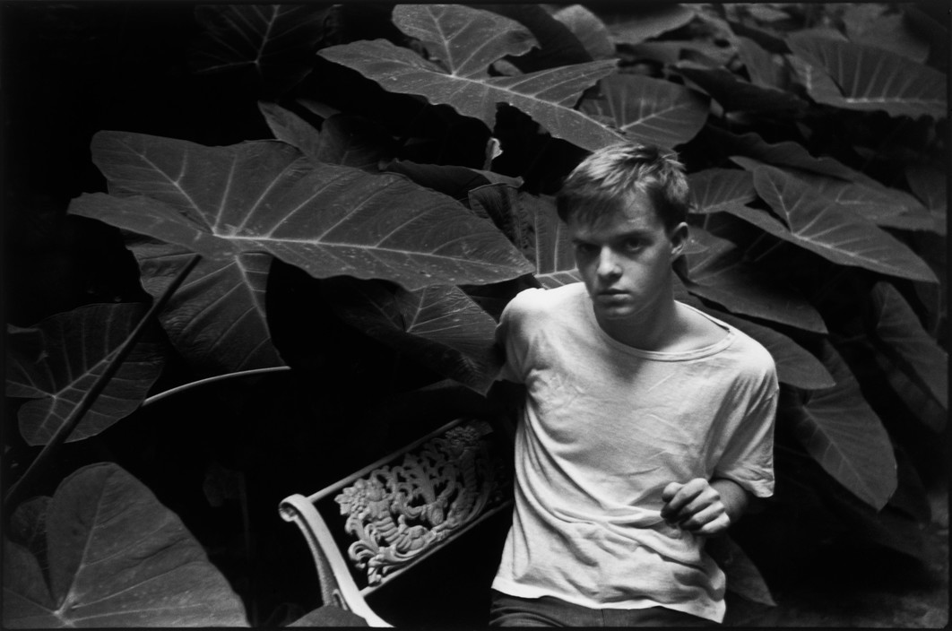

Another of Cartier-Bresson's more famous portraits, I like this portrait of Truman Capote for the sense of mystery it portrays. Who is this shadowy kid in casual clothing peering at me? What's with this eerie garden? Where was this even taken, and is it indoors or outdoors? No answers will be provided by this photo or the unassuming figure within it. Although he was actually about 23 years old when this was taken, Capote's especially young-seeming appearance seems appropriate, as he started writing at a very young age and was perceived as a promising young writer at the time of the photo. The mysterious vibe of the photo also fits well with Capote's work; his most famous short story at the time, "Miriam," was described as having a "dreamlike, psychological quality" (Stanton, Robert J., as cited in "Miriam (short story)"), and his most-famous works such as *Breakfast at Tiffany's* and *In Cold Blood* would later have a similar quality of mystery. Technically, the photo is interesting, with the negative space framing Capote well, and the limited light from above creating interesting shadows on Capote's face.

### Sources

* "Henri Cartier-Bresson: Photoportraits." *Magnum Photos.* <https://www.magnumphotos.com/arts-culture/fashion/henri-cartier-bresson-photoportraits/>
* Kuiper, Kathleen. "Truman Capote." (2019) *Encyclopedia Britannica.* <https://www.britannica.com/biography/Truman-Capote>
* "Miriam (short story)." *Wikipedia.* <https://en.wikipedia.org/wiki/Miriam_(short_story)>
  + citation for quote: Stanton, Robert J. *Truman Capote: A Primary and Secondary Bibliography* (1980) G K Hall & Company. ISBN 978-0-8161-8108-7 p. 43

## Albert Camus (1944)

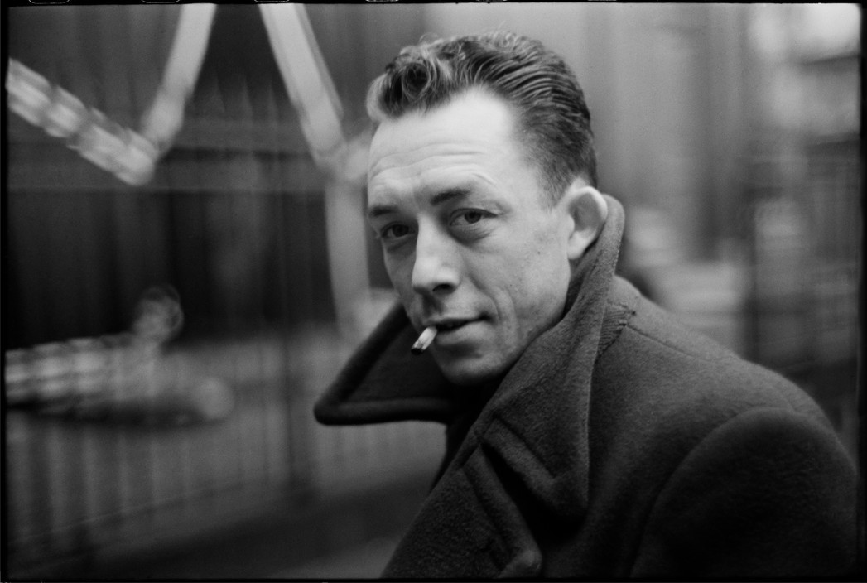

I love this photo because it perfectly encapsulates the stereotypical image of a stranger in a big city walking past on a winter night. There appears to be a bit of motion blur from panning, and the image has a very shallow depth of field which perfectly captures the details of Camus' face and nothing else. Such a shallow depth of field is often not very good for a portrait, but here it adds to the sense of motion and makes Camus seem a more intriguing figure; it feels as though Cartier-Bresson has captured a moment of clarity in a chaotic city. I think this is a very fitting portrait for someone like Camus, a journalist , author, and philosopher known for posing existentialist questions.

### Sources

* "Albert Camus." (2017). *Stanford Encyclopedia of Philosophy.* <https://plato.stanford.edu/entries/camus/>
* "Henri Cartier-Bresson: Photoportraits." *Magnum Photos.* <https://www.magnumphotos.com/arts-culture/fashion/henri-cartier-bresson-photoportraits/>

# 4. Explain your take on Cartier-Bresson's style of photojournalism? What are the similarities and the differences between his images and those of Leibovitz and Nachtwey?

Cartier-Bresson seeks to tell a story with his photos, but without drifting from or distorting the truth. Like Annie Leibovitz, his portraits often portray not just the appearance of a person, but some aspects of their personality as well; however, unlike Leibovitz, Cartier-Bresson achieves this primarily through candid photography without elaborate staging. Like Nachtwey, Cartier-Bresson was willing to travel into hostile places to capture heavy emotional scenes, but I don't think of Cartier-Bresson as being quite so stoic about his work or his photos being quite so brutal or raw (with some exceptions). Perhaps Cartier-Bresson could almost be scene as something of a happy medium between Leibovitz and Nachtwey; his work has a lot of personality and deeper meaning like Leibovitz's work, but also a lot of the direct emotion and unfiltered truth that Nachtwey's work is known for.

# 5. The body of his photographic work covers a 35-year span. During that time he covered many places and topics around the world. Choose one of those locations and describe the significance of the story or stories that he produced. Be sure to discuss the technical and emotional aspects of the images in addition to the overall story.

One of the events Cartier-Bresson is most famous for covering is the final days and funeral of Mahatma Gandhi in India in 1948. Shortly after co-founding Magnum, Cartier-Bresson traveled to India and, by some stroke of fortune, had begun to document Gandhi in mid-January, a week or two before his assassination. His photos tell a moving story of the emotional impact Gandhi had on the Indian people both before and after his death. Some of the photos I found particularly noteworthy were those of the massive crowds that gathered to honor his death; this one below is impressive for showing both the insane scale of the crowd as well as the humanity of the crowd, via the people with sullen expressions crowding the branches of a lone tiny tree.

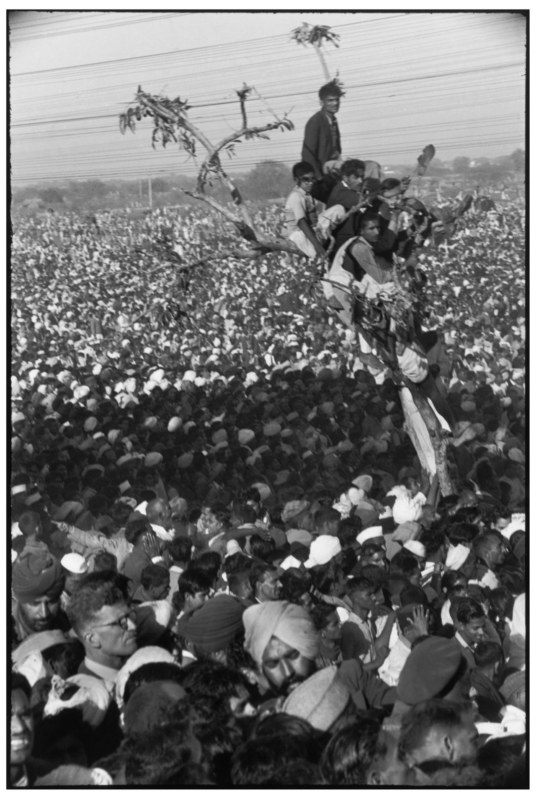

### Sources

* "India and the Death of Mahatma Gandhi." *Magnum Photos.* <https://www.magnumphotos.com/newsroom/religion/henri-cartier-bresson-india-death-gandhi/>
* Nicholson, Louise. "How Henri Cartier-Bresson bore witness to Gandhi’s death." (2017) *Apollo Magazine.* <https://www.apollo-magazine.com/how-henri-cartier-bresson-bore-witness-to-gandhis-death/>